PETER’S PORTRAIT

BE | CAN | HAVE GOT | LIKE | NOT LIKE
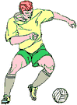  Peter | 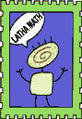  Language  HELLO | 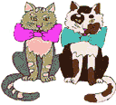 | 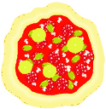 | 
Job | Language  LATHA MATH  (Gaelic) | 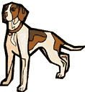 |  | 
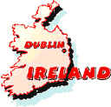  Nationality | 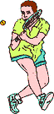  Sport | 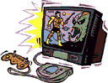 | 
Country | 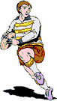  Sport |   Adventure | 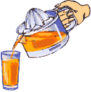
Tall |  | Green eyes
Slim |  | Red hair

